|  |
| --- |
| Department of Software Engineering  Mehran University of Engineering and Technology, Jamshoro |

|  |  |  |  |
| --- | --- | --- | --- |
| Course: SW426 - Software Quality Engineering | | | |
| Instructor | Rabia Iftikhar | **Practical/Lab No.** | 02 |
| Date |  | **CLOs** | CLO-3 |
| Signature |  | **Assessment Score** | 1 Mark |

|  |  |
| --- | --- |
| Topic | Developing Test Cases |
| Objectives | * To learn test case design |

|  |
| --- |
| Lab Discussion: Theoretical concepts and Procedural steps |

**What is a test case?**

“A test case has components that describe an input, action or event and an expected response, to determine if a feature of an application is working correctly.”

There are levels in which each test case will fall in order to avoid duplication efforts.

**Level 1:** In this level you will write the **basic test cases from the available specification** and user documentation.

**Level 2:** This is the **practical stage** in which writing test cases depend on actual functional and system flow of the application.

**Level 3:** This is the stage in which you will group some test cases and **write a test procedure**. Test procedure is nothing but a group of small test cases maximum of 10.

**Level 4:** **Automation of the project.** This will minimize human interaction with system and thus QA can focus on current updated functionalities to test rather than remaining busy with regression testing.

We can observe a systematic growth from no testable item to an automation suit.

**Why we write test cases?**

The basic objective of writing test cases is **to validate the testing coverage of the application.** If you are working in any CMMI company then you will strictly follow test cases standards. So writing test cases brings some sort of standardization and minimizes the ad-hoc approach in testing.

**Example**

Title: Login to the website or app  
Description: User should be able to successfully log in to their account on the website/app  
Preconditions: User must already be registered and use their correct login details  
Assumptions: They are using a supported device or browser to log in  
Test Steps:

1. Open website or app
2. Enter the username and password in the appropriate fields
3. Click “login”

Expected Result: The user should log in successfully.

**Test case design Techniques**

The main purpose of test case design techniques is to test the functionalities and features of the software with the help of effective test cases. The test case design techniques are broadly classified into three major categories.

1. Specification-Based techniques
2. Structure-Based techniques
3. Experience-Based techniques
4. **Specification-Based or Black-Box techniques**

This technique leverages the external description of the software such as technical specifications, design, and client’s requirements to design test cases. The technique enables testers to develop test cases that provide full test coverage. The Specification-based or [black box test](https://reqtest.com/testing-blog/test-design-techniques-explained-1-black-box-vs-white-box-testing/) case design techniques are divided further into 5 categories. These categories are as follows:

* Boundary Value Analysis (BVA)
* Equivalence Partitioning (EP)
* Decision Table Testing
* State Transition Diagrams
* Use Case Testing

1. **Structure-Based or White-Box techniques**

The structure-based or white-box technique design test cases based on the internal structure of the software.  This technique exhaustively tests the developed code. Developers who have complete information of the software code, its internal structure, and design help to design the test cases. This technique is further divided into five categories.

* Statement Testing & Coverage
* Decision Testing Coverage
* Condition Testing
* Multiple Condition Testing
* All Path Testing

1. **Experience-Based techniques**

These techniques are highly dependent on tester’s experience to understand the most important areas of the software.  The outcomes of these techniques are based on the skills, knowledge, and expertise of the people involved. The types of experience-based techniques are as follows:

* Error Guessing
* Exploratory Testing

**Procedures and Steps:**

To understand the usage of test cases, one needs to understand the portions and fields of a test case template.

For understanding how to fill a test case template, a filled test case template is shown:

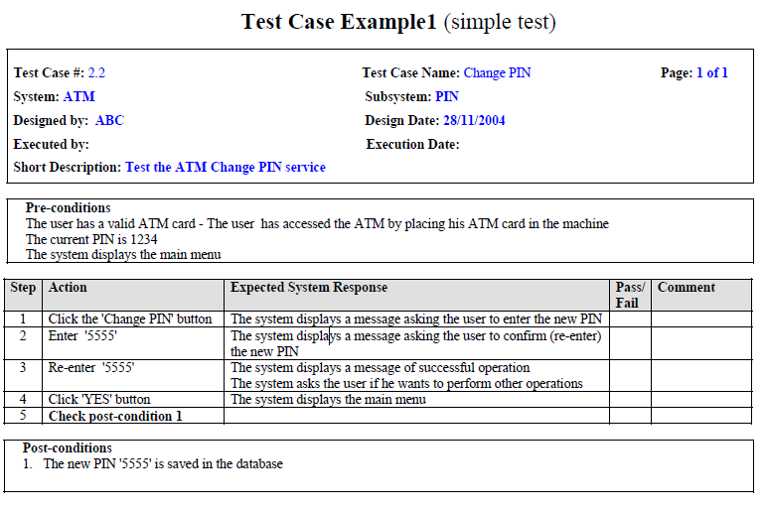**Conclusion**:

Developing Test Cases for validating system’s functional requirements and system testing is a very rudimentary practice which helps to uncover many major and minor faults in the system.

|  |
| --- |
| Lab Tasks |

1. Develop five test cases for the ATM system and fill the test case template on the next page.

**TEST CASE TEMPLATE**

|  |  |
| --- | --- |
| **Test Case #:** | **Test Case Name:** |
| **System:** | **Subsystem:** |
| **Designed by:** | **Design Date:** |
| **Executed by:** | **Execution Date:** |
| **Short Description:** |  |

|  |
| --- |
| **Pre-Conditions** |

|  |  |  |  |  |
| --- | --- | --- | --- | --- |
| Step | Action | Expected System Response | Pass/  Fail | Comment |
|  |  |  |  |  |
|  |  |  |  |  |
|  |  |  |  |  |
|  |  |  |  |  |
|  |  |  |  |  |
|  |  |  |  |  |
|  |  |  |  |  |

|  |
| --- |
| **Post-Conditions** |

|  |  |
| --- | --- |
| Lab Tasks Assessment/Rubrics along with Score/Marks | |
| *Rubric Description* | ***Rubric Marks*** |
| 1. Test case design standard | 0.25 |
| 1. Test completeness | 0.25 |
| 1. Test coverage | 0.25 |
| 1. Test correctness | 0.25 |